**FTP**

The File Transfer Protocol (FTP) is a standard network protocol used for the transfer of computer files between a client and server on a computer network. FTP is built on a client-server model architecture using separate control and data connections between the client and the server.

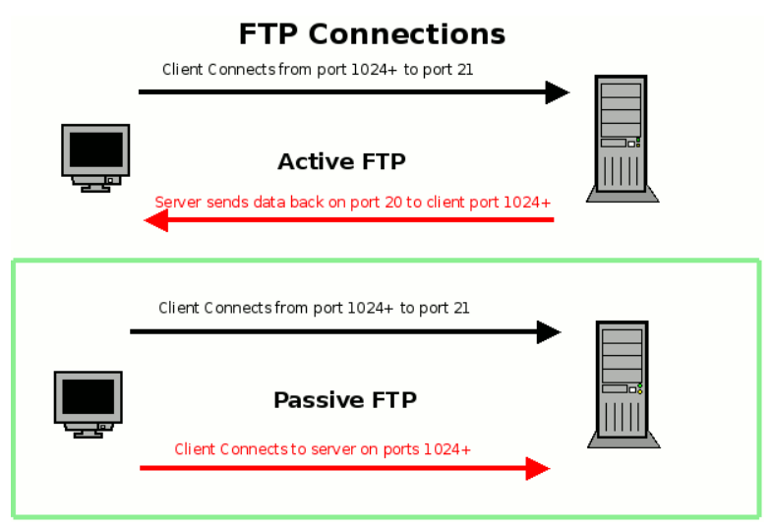

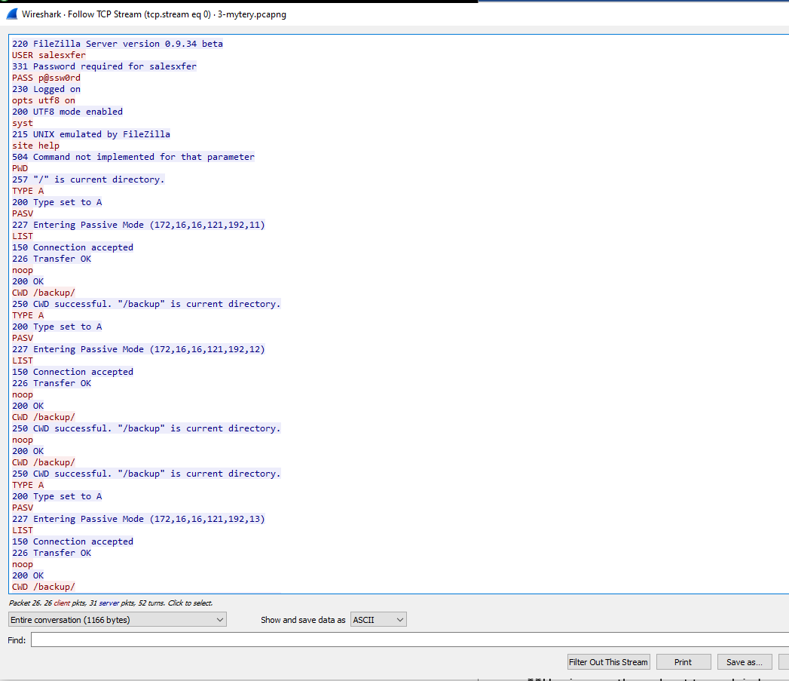

The local user at 172.16.16.121 communicating to a local server at 172.16.16.128 using the FTP protocol. After logging in with the correct password the user listed the files in the directory and then changed directories into the backup directory. Once there the user listed the files in the backup directory. The local user then downloaded a file to his computer.